How to Genrate the own private key -Linux

* Login with ***ec2-user*** (Default)

* We can user the below command for key generate (Create the own private key for rani)
* Go to rani & type the below command

ssh-keygen -t rsa

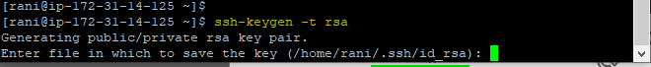

* Its asked save key

Click Enter & Enter (passphrase)

* Now we can go to ssh with belwo command

cd .ssh

* Now we can run the belwo command as

ll -a

* Now we can see the pub & private keys files in ec2 directory , we can give the authoerity for pub key now with below command

ll -a

chmod 600 authorized_keys

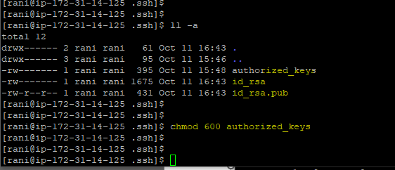

cp id_rsa.pub authorized_keys

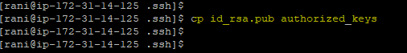

cat id_rsa

* Now you can see the private key details just selcte the key from ---BEGIN RSA to END RSA KEY

& pasted in note pad

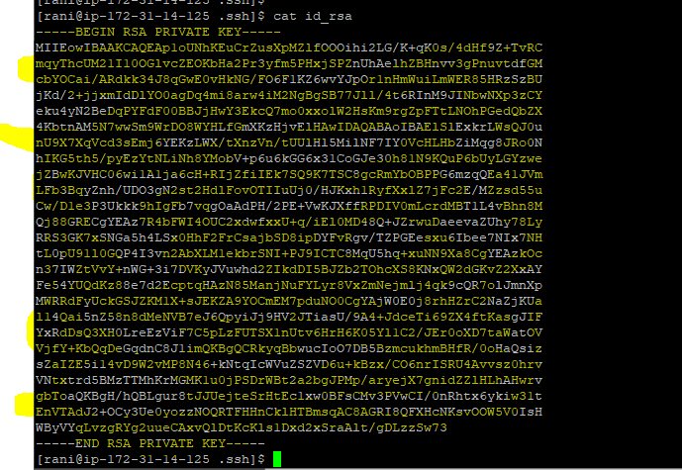

* Now the Private Key has been saved as rani.pem
* Now genrate the .ppk file from puttygen & try to login with putty app with rani user -

